9

Knowledge Bases for Clinical Decision Support in Drug Prescribing – Development, Quality Assurance, Management, Integration, Implementation and Evaluation of Clinical Value
Birgit Eiermann1,2, Pia Bastholm Rahmner1, Seher Korkmaz1, Carina Landberg1, Birgitta Lilja1, Tero Shemeikka1, Aniko Veg1, Björn Wettermark1,2 and Lars L Gustafsson1,2
1Departmentof Drug Management and Informatics, Stockholm County Council
2Division of Clinical Pharmacology, Department of Laboratory Medicine, Karolinska
Institutet, Stockholm,
Sweden

Introduction
The access and use of information technology is increasing in all parts of society and in particular in the health care sector in developed and developing countries (Bates & Gawanda, 2003; Lucas, 2008). The integration of health information technology into health care institutions governs the agenda in most countries presently (Lucas, 2008; Gustafsson et al. 2003). The US has recently enacted a $ 19 billion program to promote the use and adoption of health information technology (Blumenthal, 2009) and information systems including electronic health records (EHR). This program is seen as an essential component to improve the health of every American. Challenges discussed span over the whole area of installing electronic health records, supporting and updating the systems, assistance with the interoperability, training the personal, and implementation of the systems as well as medical education (Blumenthal, 2009). Information technology, in particular computerized decision support systems, is also seen in the recent report by the Institute of Medicine in the US as a key way to address the identified great risk of medication errors in American health care institutions (Aspen, 2006).
A recent European report published by the Swedish government analyses health care in 6 European member states. The report describes the impact of health technology on several political goals such as increasing the availability of health care, continuity, empowerment of patients, patient safety and quality of care. It states that in the 6 European member states studied, 100 000 yearly inpatient adverse drug events (ADE´s) could be avoided through usage of computerised physician order entry systems (CPOEs) with clinical decision support (CDS), which would correspond to a yearly saving of 300 million € (Gartner, 2009). This report combined with other studies and reviews (Sjöborg et al, 2007; Kelly et al., 2006) underlines the complexity of integration and implementation, including local conditions, the involvement of stakeholders and adoption and measurements of changes, all of which have

to be tackled for a beneficial usage of the technology. The Gartner report envisages that increasing costs within the health care sector will accelerate the efforts to develop new technologies as well as lead to a beneficial usage of existing systems.
Computerised physician order entry systems (CPOEs) are one step towards increased safety in patient safety. They allow physicians and other health care staff to prescribe patient medication directly by using a computer, replacing hand-written orders, and thereby eliminating possible interpretation and transcription faults. Transcription and/or interpretation errors have been shown to cause 11% of all medication errors resulting in adverse drug events in hospitals (Krahenbuhl-Melcher et al., 2007). An additional step to improving patient safety and efficacy in the prescribing process is the integration of clinical decision support systems (CDS systems) within the CPOEs. This allows physicians to retrieve up-to-date medical knowledge of the optimal/recommended management of the diseases and drugs, thereby improving patient care through enhancing compliance with recent guidelines and recommendations. CDS systems deliver their information through knowledge bases (e.g. drug-drug or drug-food interactions, drugs & pregnancy, drugs & lactation, drug dosage according to kidney function and genotype and in risk groups), which are integrated through software algorithms, that will generate alerts, warnings and recommendations during drug prescribing. For optimisation of the effect of CDS systems, they should be integrated into EHRs´ resulting in patient specific recommendations and alerts using patient characteristics available in the EHRs.
Numerous studies have demonstrated positive effects of CDS systems in various settings including hospital or ambulatory care, intensive care units and in pediatric care (Ammenwerth et al. 2008, Eslami et al. 2008, Wolfstadt et al. 2008, van Rosse et al. 2009). Areas of improvement identified include costs, safety, adherence, alerts, user satisfaction and time. Reduction of medication errors have been demonstrated with the introduction of CDS systems as well as reduction of ADE´s. However, further studies are needed which focus directly on patient outcomes rather than the surrogate outcome such as “practitioners’ performance” to further accelerate their introduction (Garg et al., 2006). Many studies pinpoint improvements of the knowledge bases or CDS systems including optimization of the content (Luna et al. 2007), introduction of classification systems to knowledge bases (Böttiger et al., 2009), and tiering alerts through introduction of severity levels (Paterno et al., 2009). Their introduction is likely to further improve CDS systems.
Evidence is growing though that CDS systems might not only lead to improved quality in health care but they can themselves create unintended errors jeopardizing patient safety (Ash et al., 2004). Introduction of CDS systems might cause diminished medical judgement, letting the computer overrule physicians´ own professional knowledge. Additional work tasks might create disturbances in the already burdened physicians work flow resulting in inefficiencies of the systems. Also the complexity of the systems increases the potential in design flaws thereby actually introducing new errors rather than preventing them (Bates et al. 2001). Therefore, the implementation and use of any CDS system should be linked to the establishment of a medical management, maintenance and quality assurance system, which leads to discovering, analysing and foreseeing possible errors.
Being responsible for paying the drug bill Stockholm County Council, the largest health care provider in Sweden, implemented a health care strategy in 1997 including the development of an IT architecture (Sjöborg et al., 2007). The aim was to provide numerous services to the prescribers to ensure safe and effective drug prescribing. Additional initiatives where

started, like the formation of drug expert groups providing a Wise Drug List, which contains a list of about 240 first line drugs for common diseases incorporating therapeutic ladders or guidelines. Recommendations from 23 expert groups and 5 local drug and therapeutic committees are used to produce and refine the guidance. On the IT site Stockholm County Council in collaboration with Karolinska Institutet and other academic partners has designed, developed and implemented a prescribing tool (Eliasson et al., 2006) and the content for medical knowledge bases for drug-drug interactions, Sfinx (Swedish Finnish Interaction X-Referencing), drugs & pregnancy, and drugs & breast feeding (Nörby et al., 2006, Böttiger et al., 2009). The knowledge bases are integrated into clinical decision support tools (Janus toolbar described below) or are accessible through the web (www.janusinfo.se). This strategy has been combined with a range of initiatives to promote rational use of drugs as described by Godman et al., (2009). The different knowledge bases and their life cycle from development to evaluation are used as examples for our own experiences in the following parts.
The review is based on more than 10 years experiences from joint efforts to develop, implement and evaluate user friendly and effective decision support systems for drug prescribing in Stockholm. It summarizes state-of-the art knowledge on development, integration, maintenance, implementation and evaluation of knowledge bases and CDS systems used for rational drug prescribing. Consequently, we see this review as a first step in the process of creating robust future models and international standards for the retrieval of medical and pharmacological knowledge, its conversion and organisation into knowledge bases, as well as their integration into CDS systems, their management and evaluation of user satisfaction and treatment outcome.

Development of knowledge databases
Why are knowledge bases needed and what advantages do they offer compared to other sources like e.g. the official product SPC (summary of products characteristics) issued as part of the registration of a drug product? One advantage with knowledge bases is the standardisation of information for all drugs containing the same substance. For instance the content of individual SPCs or physician desk references may vary considerably between drugs containing the same substance and with identical drug formulations produced by different pharmaceutical companies. This can cause confusion for the prescribing physician. For example information about drug-drug interactions can be found in the SPC for drug A from provider 1 but is missing in the SPC for the same product from provider 2. Alternatively, the drug-drug interaction between drug A and B can be found in the SPC text for drug A but not for drug B (Bergk et al., 2005). Another example for inconsistencies is the classification for drug and pregnancy alerts for pharmaceutical products. One provider may state, that the drug should be avoided during pregnancy, but another drug company may state, that the drug can be used without any problems. Other examples are variations in dosing information (maximum recommended therapeutic dose) between SPCs´ from different providers or in information published by the US Food and Drug Administration (Seidling et al., 2007). Consequently, knowledge bases should help by providing more consistent information about the substances and drugs related to that substance.
The starting point for development of any knowledge base is the analysis of the perceived needs of the potential users in the health care system (Revere et al., 2007). Likewise it is important to assess the potential of a new knowledge base to improve efficacy and safety in

drug prescribing (Gustafsson et al., 2003; Schiff & Rucker, 1998). We believe the formation of user groups should be mandatory to explore the functional and content needs for a knowledge base and decision support system before other activities are undertaken (Eliasson et al., 2006). Consequently, a multidisciplinary group of clinical experts within the medical field the knowledge base should be aimed for (e.g. nephrologists for a database about drug dosage in patients with reduced kidney function) together with drug experts (e.g. clinical pharmacologists specialised on drug dosage, drug-drug interactions or drugs & lactation depending on the knowledge base), future users, experts within existing drug registries and software developers, should be convened to discuss the potential and obstacles for the knowledge base (Ash et al., 2004). Our own experience is that there often is a mismatch between users’ expectations and the clinical and medical research basis or the availability of certain parameters or features within existing registries. For example, the clinical specialists will focus on one specific recommendation for the most common indications for both drugs for a certain drug-drug interaction. However, this recommendation might not fit all patient cases for which this pertinent drug-drug interaction alert will be shown, leading sometimes to suboptimal recommendations.
Another example is that the recommendation to achieve a certain therapeutic drug concentration interval can only be given, if there is scientific evidence. In addition, even though the potential user of a knowledge base (the general practitioner or any other physician) and the drug expert have the same basic medical education, they do not “talk the same language” and medical and clinical expertise differs, with clinical experts having more knowledge about patient treatment while drug experts possess more information about the properties of the drugs used. Medical advice given by the drug expert might not suit the practical needs of the physician and on the other hand the specialist physicians´ needs may not be fulfilled due to missing medical evidence.
It is also very important to clarify when CDS systems or knowledge bases can help and when they can’t. For example, during the development of the drug-drug interaction database Sfinx one of the future users mentioned, that he now finally can detect all the drug interactions for herbal drugs his patients always take. But since this physician never enters herbal drugs to the patient’s drug list, because he is not prescribing them, he will never get a warning for these drugs.
Prior to the development of the content of a knowledge database the multidisciplinary group needs to define its structure. For example developing the drug-drug interaction database (DDI db), Sfinx, physicians wished not only to receive warnings on certain drug interactions, but also recommendations on how to avoid and handle this interaction (Böttiger et al., 2009). The recommendation part is extremely important, since physicians do not only want warnings on avoiding certain drug combinations, but would like a recommendation how to handle the situation. In a survey among prescribers and pharmacists in the US both groups demanded that drug-drug interaction alerts should be accompanied by management options of the DDI (Ko et al., 2007). In a recent Australian study (Sweidan et al., 2009) recommendations for handling of drug-drug interactions were seen as a quality measure for the DDI databases. However, comparing 9 drug interaction systems used in primary care only 1 out of 9 systems provided useful management advices. A number of studies have demonstrated, that physicians need timely, easy to digest and up- to-date information, which is filtered, summarized, and synthesized from reliable sources by clinical respected experts (Revere et al., 2007; Grol & Grimshaw, 2003; Schiff & Rucker,

1998). The expert group needs to define the relevant sources to be used for the knowledge base, which might consist of recent research publications, legal documents, information from pharmaceutical companies, textbooks, and other databases. It is critical for the integrity of the knowledge base to use scientifically rigorous methods for evaluation of scientific data by applying critical drug evaluation principles (Godman et al., 2009). Search strategies have to be developed and documented in standard operation procedure protocols (SOP´s) to assure reproducibility of the search results (Böttiger et al., 2009). This is critical in all cases but especially if different people are executing the same task or if expert groups are located in different places and can not communicate with each other on a daily basis.
Figure 1 describes the process from filling a knowledge base with data to providing it to the end user. Literature searched will be evaluated by different experts regarding their clinical relevance and their level of documentation according to standardised rules. It will then be synthesized into short text messages, according to a predefined structure (Böttiger et al., 2009). Different content providers have to use the same tool for data entrance. It is advisable

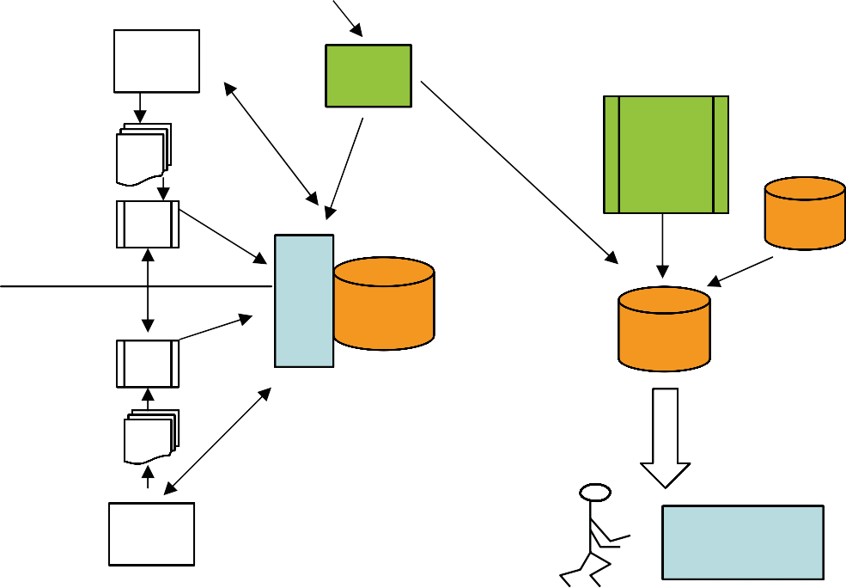
Knowledge provider 1
External supplier
pharmacists
physicians clinical pharmacologist
Literature
search
substance
registry
evaluation
Drug
formulation classification file
Drug
registry
Tool
for data en- trance
Exportfile
Interaction
DB
Sfinx DB
evaluation
End user
pharmacists
physicians clinical pharmacologist
Literature
search
User comments; feedback
www.janusinfo.se
Janus toolbar
Knowledge provider 2

Fig. 1. The design and process of building and maintaining a knowledge base to be integrated into CDS systems for drug prescribing at point of care or accessible through the web. User feed back triggers new literature searches and improves the quality of the knowledge base. This figure outlines the data management process for the drug-drug interaction database Sfinx (Böttiger et al., 2009).

to define in advance certain standard terms for the text messages to avoid heterogenicity in the text content. It is easier for the end user to recognise standard phrases for certain conditions or recommendations.
Data are entered into the knowledge base and connected to various other registries or databases to assure optimal usage in the CDS system used by the prescribers. We have experienced, that access to experts is always the bottleneck in the production of knowledge bases, which agrees with the experiences by Kuperman et al. (2006). Consequently, data entrance into the knowledge base has to be simplified to save valuable expert time. For example through an easy text sharing function the experts should be able to reuse the same texts in different documents (e.g. interactions), which follow the same interaction mechanisms and rules, as a result reducing both the time for entering data and the size of the database. We have developed a terminology model for substances so that substances within a class such as different salts of the same substance belong to the same mother substance, if they react in the same way (Böttiger et al., 2009). The grouping of substances and text sharing function results in an effective and easy way to use the tool which simplifies data entrance and database updates.
Knowledge bases need to be connected to certain registries through software algorithms for their optimal use (see Fig. 1). Because texts in knowledge bases usually are written on a substance basis they need to be linked to specific drugs which contain the substance. This linkage can be done using substance registries, which contain substance names and drugs connected to the substance. Key fields for the linkage can be:
- ATC (Anatomical, therapeutic, chemical classification) codes
- CAS (Chemical Abstract Service) numbers
- other nationally available unique identifiers (Böttiger et al. 2009).
All systems have advantages and disadvantages. The ATC code system is valuable since it takes indications of drugs into account. This can be used to link or exclude drugs containing the same substance, but with different formulations or used in different strengths. A disadvantage of the ATC code system is the handling of combinational drugs, where the content of the drug most often is not specifically defined by the code. CAS numbers identify each substance in a unique way, which allows correct linkage. Problems within the system are its complexity. For example a substance which appears to be the same might have a different CAS number due to its varying content of crystal water, which is not obvious from the description of the drug. Another disadvantage is the limited use of CAS numbers in national registries. National identifiers might be the optimal way for linkage of knowledge bases to drug registries. However, substance based national identifiers do not take drug dosages into account. A substance can have a different interaction profile due to variations in dose (for example: high-dose versus low-dose acetylsalicylic acid). Consequently linkage just by a substance identifier would lead to wrong interactions alerts. Another disadvantage of national identifiers is, that the national identifier can’t be used across nations, a problem we faced for the Sfinx database distributed in Sweden and Finland. Whatever registry or system is used for linkage it is of great importance to ensure correct update and maintenance of the registries as described in the next chapter.
If drug formulations are relevant for the triggered alert, these should be taken into account. Even here it is important to simplify matters for the knowledge expert and create drug formulation groups (e.g. all sorts of tablets, capsules or oral solutions should be grouped under the term “peroral”). The Swedish drug registry contains about 650 different drug formulations, which we have grouped into 5 different groups in the “drug formulation

classification file” (Fig.1) to support data entrance. International standard terms are needed to reduce the work load for a single country and to facilitate the integration with other drug registries from other nations. To our knowledge there is no European or worldwide registry with standardised drug formulations available, which could facilitate integration of knowledge bases across countries.
Finally database updates have to follow the same procedures and rules as defined for the starting phase. Ideally, they should include incorporating the handling of end user comments and feedback for further improvement and refinement (Böttiger et al., 2009). Each specific update should be tested, documented and saved in order to be able to trace back incorrect alerts reported by the end users.

Combined quality assurance for knowledge bases and linked registries
Quality assurance of the knowledge bases and their linkage to other registries is an essential task often forgotten as it is time consuming, labour-intensive and requires significant effort and expertise. Quality assurance does not only refer to the medical content in question but stretches over the whole procedure from literature searches, the evaluation process to the linkage of the knowledge base to local or national registries and thereby requires experienced multidisciplinary staff.
Literature about quality assurance processes within clinical databases is limited. Quality assurance papers in medicine mainly deal with securing the quality for a certain medical treatment or procedure, but are not extended to databases and CDS systems. It is amazing that still today EHRs or CDS systems do not need to be certified by health or medical agencies. However, due to the increasing awareness of the possibility that information technology implemented into health care can actually increase the error rate even with risk for higher mortality rate (Han et al. 2005), changes are on their way both in the US (Blumenthal, 2009) and Europe (EU directive; 2007/47/EC;2007). Certification should cover not only the technical part of these systems, but should include even the medical content of knowledge bases integrated into CDS systems and implementation of the systems.
Quality assurance is mostly self evolving during the development phase of any database system including the handling of external registries for linkage purposes. Baorto et al. (2009) describe the experiences they made with the maintenance of a large medical ontology at one of the larger hospitals in New York. They state that the methods described even though developed specifically for their system can be used for carrying out similar tasks at other institutions. Many of the problems and procedures mentioned mirror exactly the situation with the development of our knowledge base systems. In our mind resources and expertise for quality assurance processes are needed for integration and maintenance of high quality knowledge bases. Standards need to be developed in this area.
Combining different registries or other knowledge sources has to be performed using “key fields” like ATC codes, specific identifiers, or CAS-numbers. We were surprised though when comparing different registries that the information in key fields could vary. For example a drug could be assigned to a specific ATC code in one registry and this could vary from the code in another registry. This could be due to simple typing mistakes, system requirements of the registry owner, delays in the update process or other possibilities. We, like Baorto and colleagues (2009), used the “diff approach” for detection of theses variations, where you compare two registries regarding the information in predetermined fields using the information in key fields to link the registries. For example we assume that a drug with a

specific registration number has to have the same name, ATC code and drug formulation in all registries. Another approach to detect variations is to compare an older version of the same file with the newer one discovering changes for already existing fields, and new posts entered to the file. Logs are produced during the comparison process, which mainly have to be evaluated manually. Possible mistakes are corrected in the registries and reported to the source owners for correction in the original source.
Over the years we have discovered many mistakes at the point of acquisition of the data including missing information in essential fields (they were either completely empty or omitted), changes in the meaning of existing codes, existence of wrong characters in the master file or creation of redundant terms. The “diff approach” is also used for updating the knowledge base system, e.g. to identify new substances on the market, which will then be added and grouped into the mother child terminology, to discover new drug formulations, which have to be included into the drug formulation file, or to seek for new drugs on the market, which have to be linked to certain knowledge bases. The linkage has to be correct both technically and content wise else care will subsequently be compromised. For example, you can’t link some new ear drops, containing a substance you already have in your knowledge base, to that base, if the text document is irrelevant for this new drug.
Auditing terminology and data structure of the registries linked to the knowledge base is mainly performed manually through reviewing log files created during the import process, which flag for changes and differences. These processes are labour-intensive and time consuming. Some of these audit processes though can be automated or at least semi- automated to save time and resources. For example, if you want to add a new substance child to the registry the hierarchy principle within your database requires the existence of the mother substance to be consistent with previously existing structures. Other examples are rules you create for maintenance purposes, like no two medications with the same registry number are allowed with different names.
As Baorto et al. (2009) stated quality assurance and maintenance of the knowledge base and its linked registries is a “mission critical” task that cannot tolerant errors. If we do not add one specific, new ATC code to a document the new drug assigned to that code will fail to be considered by the alerting system. It must be recognised though that all quality assurance processes rely at least partly on human surveillance so they are inevitably prone for mistakes. One can never be sure, that the knowledge base is completely correct. However, we can increase our confidence in the database through implementation of audits, rules and log files. This will help to create a system, which is detecting and minimising a large percentage of potential errors.
Any errors that occur through the usage of the knowledge base have to be handled by the medical management and maintenance system in a systematic way to enhance the utility of the database. This is described below.

Medical management and maintenance system for knowledge bases and CDS systems
The development and implementation of several knowledge bases, CDS systems and other IT applications within health care required the introduction of a surveillance system for possible errors introduced by its applications as an essential pre-requisite for the management of these systems. Our department has implemented a maintenance system, which allowed smooth handling of all procedures linked to its databases and depending

registries e.g. regular update processes of the medical content, improvements or changes in the graphical interface and IT structure or adapting to new external registries. At the same time the EU Directive, 2007/47/EC, amending among others the Directive 93/42/EEC (http://Eur-Lex.europa.eu) concerning medical devices is under implementation in Sweden, and supports the process by raising the requirements for software and information systems used for clinical decisions regarding individual patients.
Important parts for the function of knowledge bases and CDS systems are management, maintenance and quality assurance of these applications after their implementation, together with handling of possible errors introduced by the systems, which could be of either technical or medical nature. Clinical, medical, and pharmaceutical competences, as well as competences in various IT-areas and in implementation are needed. Additionally, complete technical documentation of the knowledge base and the CDS system as well as guidelines (standard operation procedures = SOPs´) for producing their content and its distribution have to be part of the management plan to secure standardized procedures and avoid occurrence of mistakes.
Documented incidents include all kinds of subjects i.e. requests for further information, e- services, training, as well as reporting of major or minor errors. Minor or major errors include discussions of diverse opinions about recommendations or conclusions in the knowledge base, wishes for changes in classification levels or inclusion criteria. Technically it could be problems in the applications, or its documentation, or errors regarding the technical integration including design and functionality of user interfaces. All incidents are documented in the management system. Within the management and maintenance system the experiences we have made through real incidents and errors enable us to perform risk analysis on a regular basis. This helps us to foresee and judge possible incidents, which might occur through changes in the content, the graphical interface or the technical solution of our systems.

Management of errors using root cause analysis
The medical management of incidents or errors involves the processes of discovering the incidents, collecting documentation, performing event analysis and, if required, reporting of the error as a medical event - named Lex Maria - to the authorities in Sweden (Shemeikka et al., 2008). Root cause analysis (RCA) is a technique originally developed in psychology and systems engineering to identify “the basic and casual factors that underlie variation in performance”. We use RCA to investigate errors after they are discovered. It involves critical incident reporting followed by self-managed investigation of the event involving all staff in charge. It should answer three basic questions:
- what happened?
- why did it happen?
- what could be done to prevent it from happening again?
The investigation team consists of colleagues from the department and includes everybody involved in the processes related to the incident.
In the US root cause analysis for investigations of medical errors became mandatory in 1997 for hospitals accredited by the US Joint Commission on Health Care Safety. Models used for RCA were further developed and adopted for by health care systems in other countries like Australia (Iedema et al., 2005). Though RCA used in the US and other countries only included medical procedures and not handling of errors introduced by decision support

systems, we have applied the technique for handling of our knowledge bases and decision support tools as well as the e-prescribing system. We have relied on experiences by team members from using the method in pharmaceutical companies to handle reports on adverse drug reactions, and from the health care system reporting events when harm or risk of harm for the patient has occurred during medical treatment.
Once an error of the CDS system is reported an initial rapid assessment is performed of the potential immediate and long term clinical consequences. If there is any risk for the safety of the patient or other patients due to the error, a decision is taken to shut down the e-services or keep it going whilst performing immediate changes. In these cases a report is sent to the national authorities in charge of monitoring and guarding patient safety during clinical care. The error is documented in detail often by requesting additional information from the reporter. The next step is to perform RCA to investigate the reason for the error (Iedema et al., 2005) and to suggests changes in for example the system, content, procedures or technical and user interfaces.
Incidents can be due to medical (e.g. wrong medical recommendation), pharmacological (e.g. wrong pharmacological mechanism thought to be cause for a DDI) or pharmaceutical (e.g. drugs with wrong formulations can be linked to a text) errors in the content of the knowledge base, or due to an unclear text, leading to misinterpretation. Errors in drug linkage can result in wrong alerts for a certain drug or missing alerts. The reason for the error could also be of technical nature. RCA may lead to organisational changes like education of the personal or policy changes, though they have a lower probability of reducing risk (Wu et al. 2008). It may also lead to changes of the content or processes for producing the knowledge bases or CDS systems or in redesign of the product or processes linked to knowledge base or CDS system, which are actions with a high probability of reducing risk (Wu et al., 2008). Procedural changes may lead to updates in the documentation or SOPs´ for the knowledge bases. Any changes in the device will be followed by extensive tests of the modified application before reintegration into the work environment. If the incident does not depend on one’s own systems but on the EHR the CDS system is implemented in, the health record system owner has to solve the problem and document and proof changes. These changes are performed in close contact with vendors and producers of electronic health record systems.
Other incidents like inappropriate handling of the CDS system by the user may lead to a modification of the system and if necessary, user training must be performed. An example of a RCA is shown in figure 2 and 3. It describes an incident, where an ATC code was connected to a medical document by mistake. Drug name and ATC code was incorrectly send to the authors of the knowledge base. This led to the addition of the code to the document by the authors and a wrong linkage of drugs to the document. Processes for quality assurance of linkage of drugs to documents failed due to various reasons (technical equipment; frequent change of personal involved in the process). Consequently, users searching on the web for one of these drugs in one of our knowledge bases ended up in a document which had nothing to do with the drug searched for. Even if RCA has some benefits, including increased awareness of faulty processes and fixes to specific problems, more emphasis should be placed on drawing lessons across investigations rather than to approach each RCA independently. Most important, follow-up for implementation and outcome of each RCA and its actions should become a standard element of the process (Wu et al. 2008)

Incident chain:

The new product containing tetracaine and lidocaine is added to a list in a word document with its ATC code for combination. No information is added that other drugs containing different substances use the same ATC code.

The list is sent to the clinical experts of the knowledge base.

The existing text for tetracaine in XML formate is updated by the expert due to the new product. The text is tagged incorrectly with the ATC code stated in the word document list.

An automated control is performed regarding changes of ATC code in the XML file. It is noted that a new ATC code is added to the tetracaine document.
There is no routine to state in the ATC column of the list that several drugs containing different substances share the same ATC code.
No control before updating the text, by the clinical experts, if the ATC code is shared with other drugs.

Procedures and routines: Poor procedures.

Procedures and routines.
Poor procedures.
A new routine to always add the information from the national medical products registry to the comment field in the list in cases when ATC codes are shared.

To introduce a new routine where possible shared ATC codes are stated in the list of new products.
To clarify and inform about the routine that exists where a control always should be made if an ATC code is shared by several drugs before the code is added to the list.

Introduction of an operating procedure on how changes of text in the XML file should be done.
A new pharmaceutical product, Rapydan, containing
tertracaine and lidocaine to be added to the knowledge base on safety of drugs during pregnancy by updating an existing document.
Why?
Why?
Causation:
Actions:
Fig. 2. RCA part 1: On the top of each RCA the incidents following each other and leading to the mistake are stated. Next line gives the reasoning for each incident. These are followed by the causes, grouping the reasons into categories. Each reason is followed by one or several actions suggested.

Analyses of risks
Risk analyses are also included into the management and maintenance system. Using the experiences made with existing systems we apply this knowledge to other parts of the knowledge base and the CDS system to foresee possible risks. On a regular base we perform preventive risk analysis to identify and classify different kinds of risks. The method has been adapted and is now used even during development of new CDS systems or knowledge bases in our setting in Stockholm. It improves our possibilities to evaluate the costs, risks, and improvements made with the implementation of new knowledge bases or decision support tools. For example when the graphical interface of the decision support system is changed risk analysis can be performed on possible effects for end user performance.

Providing medical knowledge bases at point of care
The knowledge base can either be provided:
- as a website solution
- integrated into EHR systems
- used in learning tools.
The integration into EHR systems facilitate the exchange of patient-specific data with the knowledge base, thereby creating patient-specific alerts or reminders during the process of

Incident chain:

The update of the tetracaine document with the new ATC
code that is shared with other
drugs is controlled, accepted and added to the knowledge base.

Pharmaceutical products that don´t contain tetracaine but share the same ATC code are seen on the web wrongly when reading about tetracaine.

Why?

Why?

It is not observed that through the ATC code also other drugs are connected to the text

Unclear description manual of the routine how the ATC code control should be performed.

Short time to introduce new personal to the control process.

The persons performing the control were changed repetedly and didn´t initially know the routines.

The technical application performing the control has technical deficiencies and its easy to loose control of how far in the process the test has come.

Causation:

Procedures and routines: Poor routines

Management system: Education lacking

Management: Poor planning.

Technical equipments and tools: Deficient tool.

Actions:

Change in the routine description for how the control step of the text has to be performed added details how to control the ATC code.
Improve and increase the time for education of new staff members in the routines of the control step.

Policy change: personal performing the control step shouldn’t be replaced that frequently .

Clarify and inform how routines should be in order to avoid the system tool to crash during the control step.

A new technical application for the control step of the texts .

Fig. 3. RCA part 2: the second part of the incident chain explains, how the document with the wrong ATC code was added to the database without proper controls of the document and the effect it had on the linkage of drugs to the document. Actions suggested include changes in routines and policies, education and even changes in the technical tools used.
drug prescribing. The integration into an EHR system should be performed in collaboration between the providers of the knowledge base and the owners of the EHR systems. Contracts should specify the implementation of the database and how it is to be used and presented to the end user. The organizations implementing CDS systems must have detailed knowledge of the structure of the knowledge base and the architecture of the CDS system so that it is clear, how the systems interact (Kuperman et al.2006). Intensive testing of its integration following predefined protocols should be required to avoid unintended errors or mistakes due to lack of experiences and knowledge of the product. One must be sure that the knowledge base is behaving as intended (Kuperman et al. 2006).
The knowledge bases for drug-drug interactions, Sfinx, drugs & pregnancy and drugs & lactation produced by Stockholm County Council are provided free of charge through the county website on www.janusinfo.se. The website is aimed at health care personal. Physicians or nurses can search various knowledge bases by typing in the patient’s medication and receive advice, whether specific drugs can be used during pregnancy or breast feeding or should be avoided (Norby et al., 2006). Drug-drug interactions can be searched for in Sfinx by either substance or drug names.
However, for optimal use knowledge bases should be implemented into a CDS system linked to an EHR, which will send patient specific data such as age, sex, height, weight, parameters for kidney function and the current drugs a patient is being prescribed to the

knowledge base. Through certain software algorithms an alert or reminder could then be triggered or not, providing patient specific warnings for e.g. drug-drug interactions, drugs
& lactation or drugs & breast feeding.
The DDI database Sfinx is integrated into the CDS system Janus toolbar, providing patient specific automatic alerts during drug prescribing (Sjöborg et al., 2007). In figure 4 we describe an example of the decision support system provided through Janus toolbar integrated into one EHR system in Stockholm County Council. The patient’s name, sex and age can be seen at the top of the screen. The prescribing module within the EHR contains the current drug list, consisting of 4 different drugs. Sending those data to the knowledge base for DDIs´, pregnancy and breast feeding the alert buttons will be illuminated, if there is any information to be retrieved (Eliasson et al., 2006, Sjöborg et al., 2007). It is of great importance that the EHR and the knowledge base interact in an optimal and correct way. For example in a survey among ambulatory care clinicians in Massachusetts it was observed, that the local CDS system often delivered alerts with out-of-date medications, which led to scepticism towards the system among users (Weingart et al. 2009).

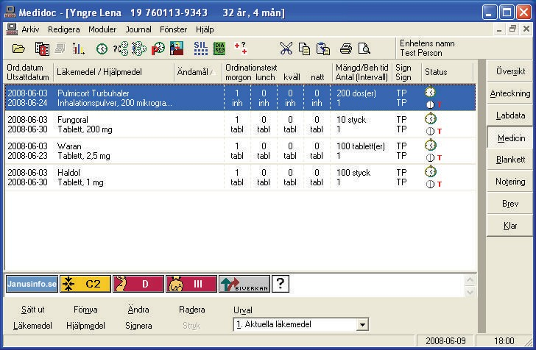
Patient name
Patient drug list

Shortcut to website
DDI alert
Drug & pregnancy alert
Drug & breast feeding alert
Table of side effects
Fig. 4. Implementation of Janus toolbar into an EHR. Patient specific alerts are illuminated related to the patient’s age, sex and current list of drugs. Several different knowledge bases are the basis of the decision support system. For every new order of medication a new drug list will be send to the knowledge base, evaluated and may lead to changes in the alerts.
To further improve user friendliness, accessibility, and speed of the CDS system the most important information of the knowledge base should be short and concise only one click away. This principle is implemented into the Janus toolbar with the most important message

being provided immediately, while for information about possible mechanisms, background studies for the statement and references users have to click further (Eliasson et al, 2007, Böttiger et al. 2009). We believe this quick access to pertinent information enhances the utilisation of the support tool. Even other surveys have shown that important information should be easily accessible and speed of use is a critical factor for the successful use of medical information systems (Dawes & Sampson, 2003; Bates et al., 2001).
Figure 5 shows the information provided by the knowledge base for drug-drug interactions,
- Sfinx. Sfinx was developed by us together with partners from clinical pharmacology in Finland and in Sweden (Böttiger et al., 2009). Clicking on the yellow alert button, which is illuminated according to the patients’ drug list, short and concise information about the medical consequence and recommendations can be seen immediately. Additional more educational information is available through clicking on the “read more” button.

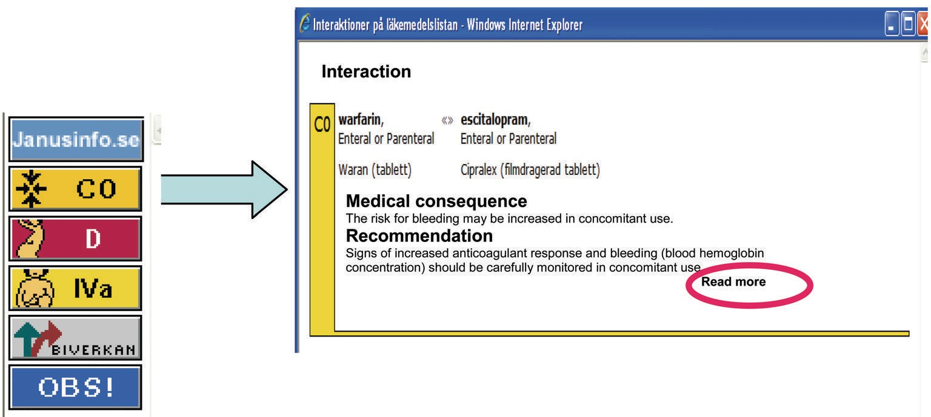
Fig. 5. Warning texts of the drug-drug interaction database, Sfinx. The yellow colour code is used for interactions classified as “C” which means, that the interaction is clinical relevant but the drug combination can be handled by for example dose adjustment (Böttiger et al., 2009). A short consequence text describes, what can be expected medically. This is followed by a recommendation part, stating how to handle the interaction.
The Janus toolbar alert system delivers non-intrusive reminders. This means that the illuminated warnings are optional not forcing the physician to take any action and not disturbing the workflow for the practitioners. Shah et al. (2006) showed that acceptance of drug alerts was improved by minimizing workflow disruptions, designating only high severity alerts to be interruptive to clinicians work. Disadvantages with intrusive alerts are disruption of physicians’ workflow and increased tendency to ignore, work around or override these warnings. In a survey by Krall & Sittig (2001) physicians indicated that intrusive or active alerts might be more useful but less easy to use. It was also stated that another important factor for increased compliance and effectiveness of a CDS system is the interface design in relation to the workflow process. Alerts showing up too early or too late in the workflow process might lead to decreased compliance and reliability of the users in the system or even worse, lead to errors and harm for the patient (Krall & Sittig, 2001; Khajouei & Jaspers, 2008).

